HR Analytics: Workforce & Attrition Analysis
Week 6 Final Data Analytics Project
Prepared as an editable academic project template. Replace student details and add your actual Power BI dashboard screenshot before submission.

Dataset disclosure
The included dataset is synthetic and generated for educational demonstration. It does not represent a real company or real employees. All metrics and findings below are illustrative.

Task 1–2: Git & GitHub Basics and Workflow
Install Git, configure your name and email, create a GitHub repository, clone it locally, add the project files, commit the work, and push it to GitHub. Practice git clone, git add, git commit, git push, and git pull. The accompanying GIT_WORKFLOW.md contains commands and three meaningful commit examples.

Task 3: Dataset Selection & Data Preparation
Project title: HR Analytics — Workforce & Attrition Analysis. The raw dataset contains 502 rows including intentionally introduced duplicate records and 13 columns. After removing duplicates, 500 unique records remain.
Columns include employee ID, age, gender, department, job role, monthly income, years at company, job satisfaction, work-life balance, overtime, business travel, performance rating, and attrition.
Cleaning process: inspect shape and data types; count missing values; remove exact duplicate rows; impute missing monthly income and job satisfaction with their medians; create numeric flags for attrition and overtime; export a cleaned CSV for Power BI.

Task 4: Exploratory Data Analysis
Cleaned employee count: 500. Employees marked as having left: 68. Overall attrition rate: 13.60%. Average monthly income: 5,923 dataset currency units. Average tenure: 4.05 years. Employees marked for overtime: 32.6%.
The notebook computes descriptive statistics, subgroup summaries, a numeric correlation heatmap, and potential monthly-income outliers using the IQR rule. Correlation is not proof of causation; unusual values should be investigated rather than automatically deleted.

Task 5: Data Visualization
Six charts are included in the visualizations folder. They compare attrition by department and overtime, average income by department, satisfaction distribution, tenure by attrition status, and age versus monthly income.
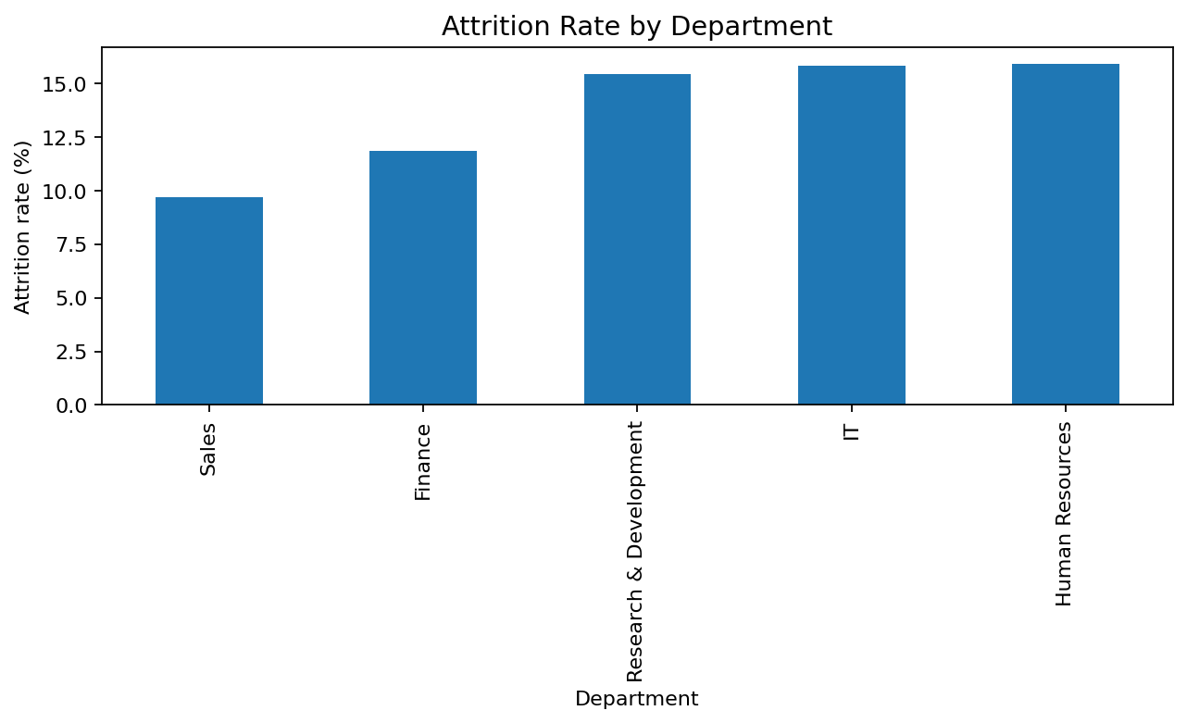
attrition_by_department.png
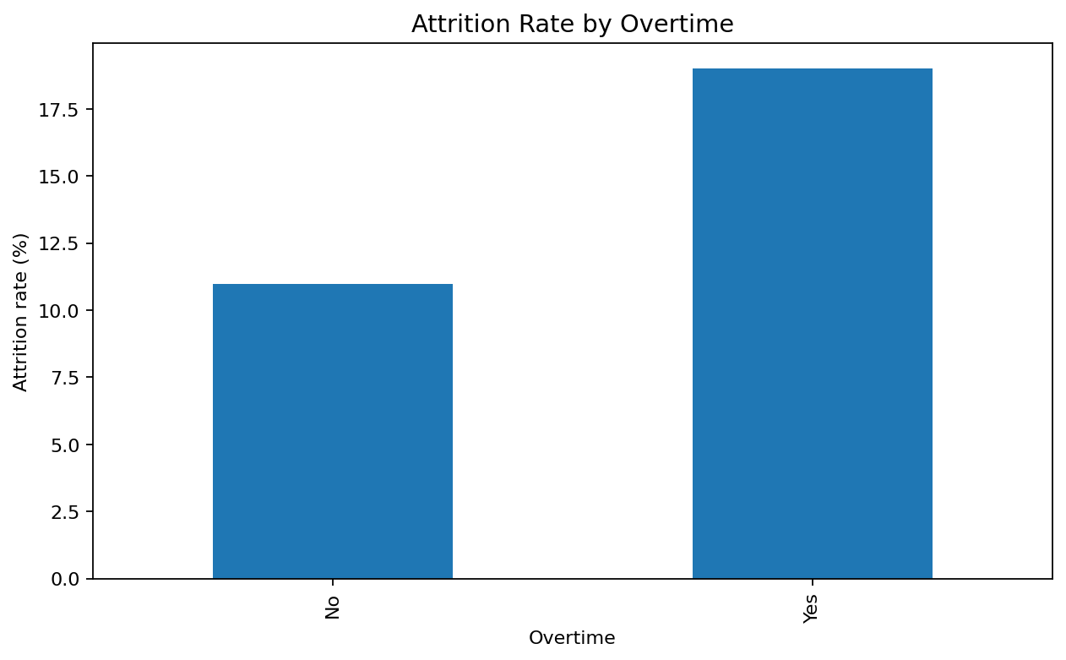
attrition_overtime.png
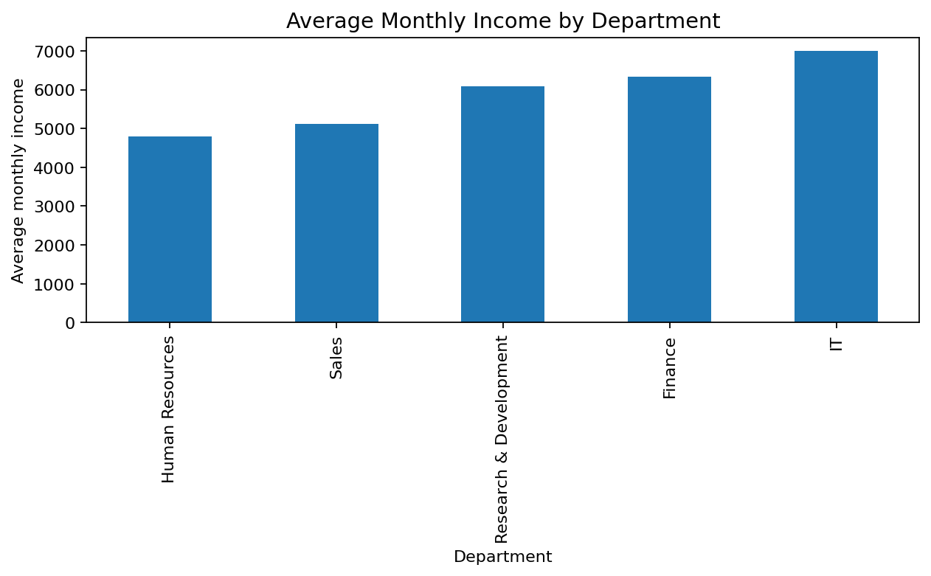
income_by_department.png
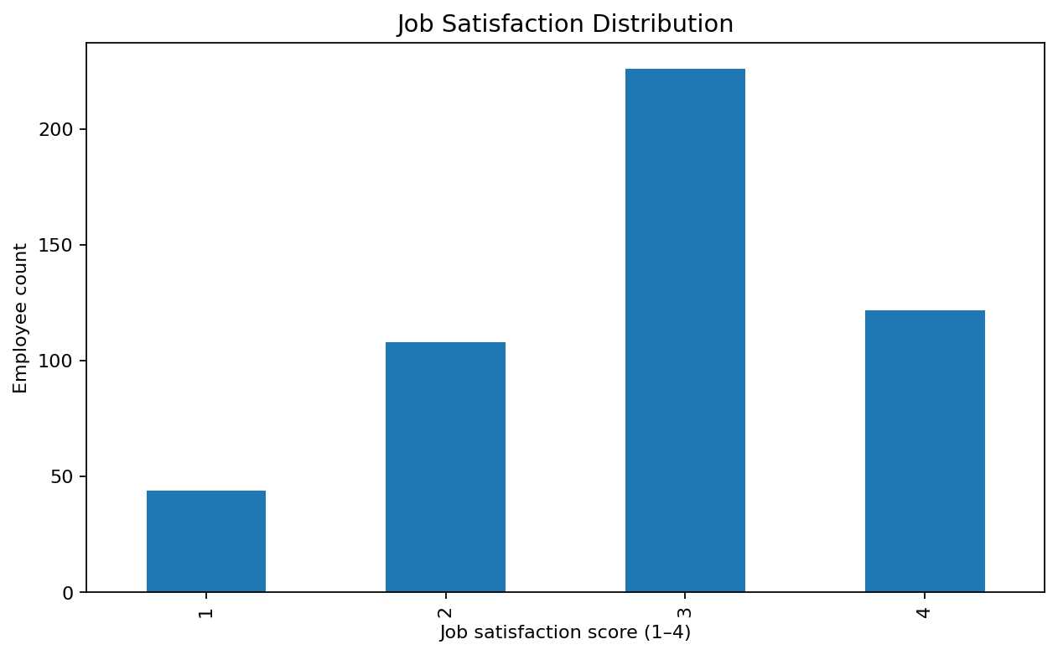
satisfaction_distribution.png
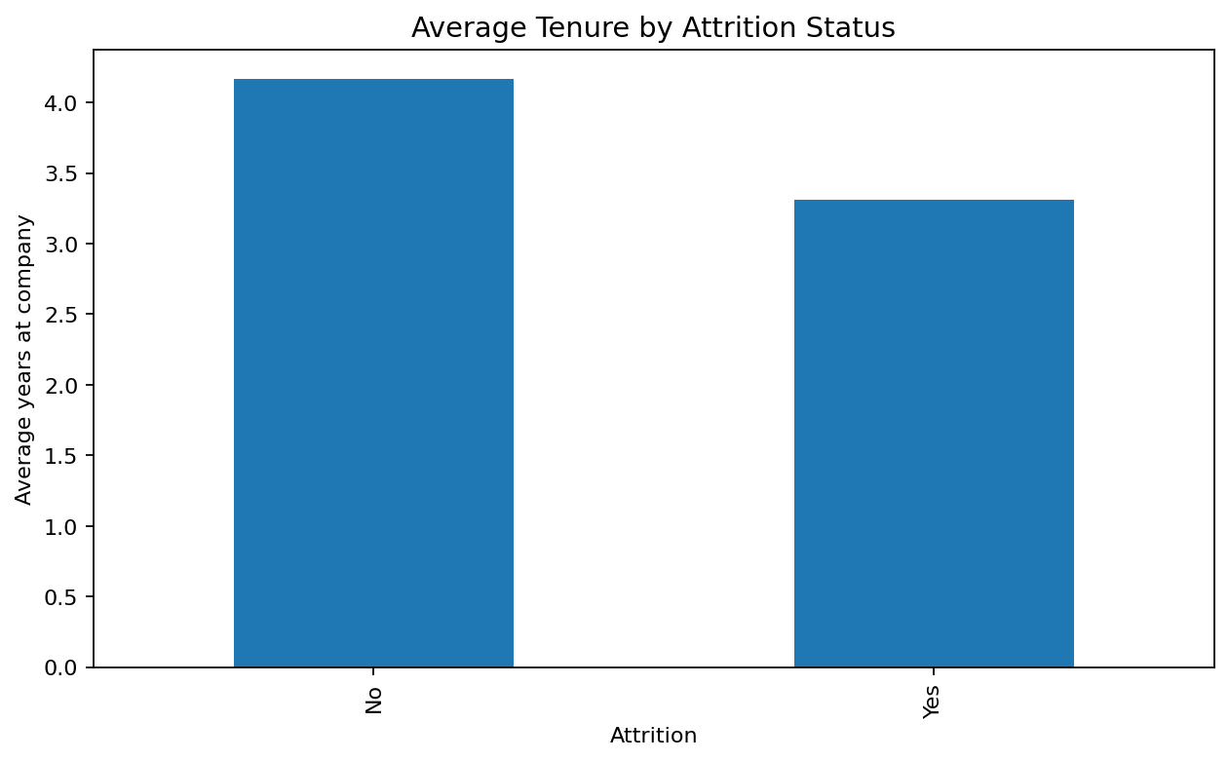
tenure_attrition.png

Task 6: Power BI Dashboard
Create a report titled HR Analytics — Workforce & Attrition Overview. Add KPI cards for Total Employees, Employees Left, Attrition Rate, and Average Monthly Income. Add visuals for attrition rate by department, employee count by department, attrition by overtime, income by department, attrition split, satisfaction distribution, and tenure versus income. Add slicers for department, gender, job role, overtime, and business travel.
See powerbi/POWER_BI_DASHBOARD_GUIDE.md for import steps and DAX measures. Build and save the actual .pbix file in Power BI Desktop; it is not generated by this report.

Task 7: Business Insights & Recommendations
Use the calculated subgroup metrics in the notebook to identify which departments and employee groups have higher attrition. Investigate the following five questions:
- Which department has the highest attrition rate, and how does it compare with the overall rate?
- Is attrition higher among employees who report overtime?
- How does average tenure differ between employees who left and those who stayed?
- What is the distribution of job satisfaction scores, and which scores show higher attrition?
- How do monthly income and department vary, and are there unusual income values worth reviewing?
Recommendations: (1) investigate high-attrition departments through stay interviews and role-specific workload/career-path reviews; (2) assess overtime and pilot workload balancing; (3) strengthen early-tenure onboarding and regularly survey job satisfaction. Validate any proposed intervention with real, authorized data before claiming impact.

Task 8: GitHub Documentation & Presentation
The repository README covers the project overview, problem statement, dataset description, tools, cleaning, EDA, visualizations, dashboard, insights, recommendations, and conclusion. A short editable PowerPoint presentation is included.

Conclusion
This capstone demonstrates an end-to-end analytics workflow: problem definition, dataset preparation, EDA, visualization, dashboard planning, and recommendations. Because the dataset is synthetic, conclusions are examples for learning and should not be presented as real-company findings.

Before submission checklist
☐ Add your name, college, and internship details.
☐ Run all notebook cells and verify outputs.
☐ Build the Power BI dashboard and save the .pbix file.
☐ Add a screenshot of the completed dashboard to the report/README.
☐ Create at least three commits and push to GitHub.
☐ Verify the public/private repository sharing settings required by your instructor.

